HEURISTICS AND BIASES IN THE BRAIN: DUAL NEURAL PATHWAYS FOR DECISION MAKING

Wim De Neys

University of Leuven, Belgium

Vinod Goel
York University, Toronto, Canada

Mailing address: Wim De Neys
Lab Experimental Psychology
University of Leuven

Tiensestraat 102

3000 Leuven

Belgium

E-mail: Wim.Deneys@psy.kuleuven.be

Fax: +32 16 326099

Tel: +32 16 326143

De Neys, W., & Goel, V. (in press). Heuristics and biases in the brain: Dual neural pathways for decision making. In O. Vartanian & D. R. Mandel (Eds.), Neuroscience of Decision Making. Hove, UK: Psychology Press.
Abstract

Human thinking has often been characterized as a struggle between an intuitive-heuristic and a more logical-analytic reasoning process. The claim that there are two different human reasoning systems received substantial support from imaging studies pointing to dual neural pathways during deductive reasoning. In this chapter we present a study that shows that the imaging findings on deductive reasoning can be generalized to decision making. We decided to unravel the neuronal foundation of one of the most infamous tasks in the Heuristics and Biases literature. Participants were scanned while they were solving classic "Lawyer-Engineer" problems. In these problems a stereotypical description cues a prepotent heuristic response that conflicts with the response based on the analytic base rate information. Results showed that, just as during deductive reasoning, belief-mediated reasoning that was based on the stereotypical description activated a left temporal lobe system whereas a bilateral parietal system was activated when the response was in line with the base rates. In addition, activation of the right lateral prefrontal cortex was evident when participants inhibited the stereotypical heuristic responses and correctly completed the decision making task. In the brain, it seems, deductive reasoning and decision making are more similar than the disseperate literatures suggest.
Heuristics and Biases in the Brain: Dual Neural Pathways for Decision Making

One of the most striking findings of cognitive reasoning research over the last decades is that human judgment frequently violates traditional normative standards: In a wide range of reasoning tasks people often do not give the answer that is correct according to logic or probability theory (e.g., Evans, 2002; Kahneman, Slovic, & Tversky, 1982). Influential dual process theories of thinking have explained this “rational thinking failure” by positing two different human reasoning systems (e.g., Epstein, 1994; Evans, 2003; Goel, 1995; Kahneman, 2002; Sloman, 1996; Stanovich & West, 2000). The common failure to provide the correct answer on reasoning tasks has been attributed to the pervasiveness of the heuristic system. It is argued that human thinking typically relies on the operation of intuitive heuristics instead of a deliberate, controlled reasoning process. Whereas the fast and undemanding heuristics provide us with useful responses in many situations they may also bias reasoning in tasks that require more elaborate, analytic processing. That is, both systems will sometimes cue different responses. In these cases the logical, analytic system will need to override the intuitive belief-based response generated by the heuristic system (De Neys, 2006; Stanovich & West, 2000). Since the analytic operations heavily burden our limited executive resources, the analytic override will frequently fail and the heuristic system will dominate our thinking.
The claim that there are two different human reasoning systems received substantial support from imaging studies pointing to dual neural pathways during deductive reasoning (e.g., Goel, Buchel, Frith, & Dolan, 2000; Goel & Dolan, 2003). For some deductive reasoning problems the logical status of the conclusion conflicts with background beliefs (i.e., incongruent items, for example, a valid but unbelievable syllogism like ‘All mammals can walk. Whales are mammals. Therefore, whales can walk’). The heuristic, belief-based system thus triggers a logically erroneous response and providing the correct response requires demanding analytic computations. For other syllogisms the logical status of the problem is consistent with its believability (i.e., congruent items, for example, a syllogism with a valid and believable conclusion like ‘All fruits can be eaten. Apples are fruits. Therefore, apples can be eaten.’). Here, the heuristic system cues the correct response and solving the problem can be based on mere belief-based thinking without any need for an additional analytic intervention.
Goel et al. repeatedly observed that reasoning with congruent items activated a left temporal system whereas a bilateral parietal system was activated when people tried to solve the incongruent problems. The parietal system was also specifically engaged when people reasoned with belief-neutral problems where beliefs neither biased nor helped reasoning (e.g., ‘All X are Y. Z is an X. Therefore, Z is a Y’) and people could only rely on logical, analytic thinking to solve the problem. This leads to the suggestion that the left temporal pathway corresponds to the heuristic system while the bilateral parietal pathway corresponds to the analytic system (e.g., Goel, 2005).
The neuroimaging studies of Goel and colleagues have focused on deductive reasoning tasks (e.g., categorical syllogisms). Deductive reasoning and decision making are both components of our system of rationality although the two literatures remain somewhat disseperate (Evans, 2002, 2003). Reasons for the sharp division are not very clear, but they may, in part have to do with the different normative theories the two domains draw upon; formal logic for deductive reasoning and probability theory for decision making. However, dual process theories have the potential of bringing the two fields together. Within a dual process framework it can be suggested that people’s deductive reasoning and decision making is governed by exactly the same machinery: The heuristic and analytic reasoning system (e.g., Evans, 2003).
In this chapter we present a neuroimaging study that examines the generalizability of the dual pathway findings to decision making tasks. We are interested in answering the following two questions: (i) Is there a dissociation in the neural systems underlying analytic and heuristic decision making as there is for deductive reasoning? (ii) Will the same neural systems that underlie deductive reasoning underwrite decision making? Affirmative answers to these questions will serve to reinforce the case for dual process theories.
We scanned participants while they were solving decision making problems that were modeled after Kahneman and Tversky’s infamous (1973) base rate neglect problems. The base rate or “Lawyer-engineer” task is a classic task in the field but despite decades of behavioral studies its neural foundations have not been explored. In the task, the correct normative answer is given by the base rates, however, an accompanying description engages heuristic processes that often override the normative response. Consider the following example:

Base rate: A psychologist wrote thumbnail descriptions of a sample of 1000 participants consisting of 5 engineers and 995 lawyers. The description below was chosen at random from the 1000 available descriptions.

Description: Jack is a 45-year old man. He is married and has four children. He is generally conservative, careful, and ambitious. He shows no interest in political and social issues and spends most of his free time on his many hobbies which include home carpentry, sailing, and mathematical puzzles.

Question: Which one of the following two statements is most likely?
- Jack is an engineer.
- Jack is a lawyer.

Logically speaking, given the size of the two groups in the sample, it will be more likely that a randomly drawn individual will be a lawyer. Hence, the normative response based on the group size information is (b). However, many people will be tempted to respond (a) on the basis of stereotypical beliefs cued by the description. Just as in the incongruent syllogisms, the logical response will conflict with heuristic beliefs and solving the problem will call for an analytic intervention.
We constructed four types of base rate problems to test our hypotheses: Incongruent, Congruent, Neutral Heuristic, and Neutral Analytic items. In the Incongruent items the heuristic response conflicted with the base rates as in the classic, standard version. In the Congruent items the base rates were switched around (e.g., 5 lawyers and 995 engineers) so that the heuristic description was consistent with the normative response. Hence, contrary to the classic problems, base rates and description will not conflict and the response can be rightly based on the cued heuristic beliefs without any need for further analytic intervention. In the Neutral Heuristic items the description was completely neutral (e.g., ‘Jack has brown hair and green eyes’). Hence, the item will not trigger a stereotypical heuristic response and participants should have little trouble to reason analytically and rely on the base rates to solve the problem. Finally, in the Neutral Analytic items we presented neutral base rates (e.g., ‘a sample with 500 lawyers and 500 engineers’). This control problem does not trigger an analytic response and solving it will rely on mere heuristic thinking about the description. Table 1 presents examples of the different items.
In sum, generally speaking, we can assume that solving the Incongruent and Neutral Heuristic items will be based on analytic thinking whereas solving the Congruent and Neutral Analytic items will be based on heuristic thinking. Contrasting brain activations while reasoning about the different item types should help identifying the regions engaged in heuristic and analytic decision making. Based on the Goel et al. findings from the deductive reasoning tasks we predict activations in bilateral posterior parietal areas (BA 7) during analytic thinking and left lateral temporal activation (BA 21/22) during heuristic thinking.

Method

Participants
Thirteen right-handed participants (seven females and six males) with a mean age of 27.9 years (SD = 3.7) and mean education level of 16.1 years (SD = 1.1) gave informed consent to participate in the study in return for a monetary reimbursement. All participants had lived in Canada or the United States for at least 10 years.

Stimuli
We presented four types of base rate problems: Incongruent, Congruent, Neutral Heuristic, and Neutral Analytic items. Participants solved 24 problems of each type resulting in a total of 96 presented problems. Examples of each problem type appear in Table 1.

-----------------------
Insert Table 1 Here
-----------------------

Problems were based on a wide range of stereotypes (e.g., gender, age, race, job, …). Material was selected on the basis of an extensive pilot study where a large number of stereotypical and neutral descriptions were constructed and rated. Selected descriptions for the Incongruent, Congruent, and Neutral Analytic problems moderately but consistently cued one of the two groups whereas ratings for the Neutral Heuristic items had to be as similar as possible. All 96 selected problems had a different content. The average length of the 24 selected problems for each of the four conditions was matched. The order of the two response options (‘a’ and ‘b’) was also counterbalanced. For half of the problems the correct response was option ‘a’ whereas for the other half the second response option (‘b’) was the correct one.
There were also 12 rest trials that were presented at the beginning and end of the experimental session. These rest trials showed series of X’s in place of each of the lines where the base rates, description, and question were otherwise presented. Participants answered these trials by pressing any of the two response keys.

Instructions
Before going into the scanner, participants were familiarized with the task format. They were given the following instructions:

In a big research project a number of studies were carried out where short personality descriptions of the participants were made. In every study there were participants from two population groups (e.g., carpenters and policemen). In this experiment you will have to solve problems based on these studies.

First, you’ll get information about the composition of the population groups tested in the study in question. Next, you’ll get to see the personality description of a randomly chosen participant of the study. You’ll be asked to indicate to which population group the participant most likely belongs.

Once you’ve made a decision press the corresponding key on the response box. After you pressed the key, you just wait until the next problem is presented.

To avoid repetition and to limit the amount of text presented on the screen we did not explicitly repeat the classic lines about the total sample size and random sampling in the problems (e.g., ‘A total of 1000 people were tested … The description was drawn ad random from the sample …’). However, this information was clearly stressed in the instructions. To make sure that participants grasped the concept of random sampling they could observe the actual drawing of descriptions from an urn with an example problem (e.g., Gigerenzer, Hell, & Blank, 1988). We also clarified that participants needed to think as statisticians when solving the problems (e.g., Schwartz, Strack, Hilton, & Naderer, 1991). These simple manipulations have been shown to minimize possible task misinterpretations.

Stimuli presentation
The items were presented in one of two random orders. The beginning of a base rate trial was signaled by a fixation cross that was presented for 500 ms. Next, the problem was presented in three parts. First, the line with the base rate information was presented for 4000 ms. Next, the description was presented for 5000 ms (base rates remained on the screen). Afterwards, the question and two response alternatives appeared. Once the question appeared the whole problem remained on the screen for another 8500 ms. Hence, each trial lasted exactly 18000 ms.
Participants responded by pressing one of two buttons on a keypad (half the participants used their left hand, the other half the right) after the appearance of the question. Hence, participants had 8500 ms to enter their response. Participants were instructed to respond naturally and efficiently so as to be prepared to read the next trial. They were also told to let the trial pass and to focus on the upcoming problem in the event they could not respond quickly enough.
Before or after the base rate problems had been solved participants were presented with a block of rest trials. The rest trials only lasted 9 s each. The trials started with the presentation of a fixation cross for 500 ms. Next, the first and second line of X’s were presented for 2500 ms each. Participants were simply asked to press a key once the third line (corresponding to the question) appeared on the screen.

fMRI Scanning Technique
Participants were scanned in a 4-Tesla Oxford Magnet Technologies magnet with a Siemens Sonata gradient coil at the Robarts Institute in London, Ontario (Canada). Twenty-three T2*-weighted interleaved multi-shot contiguous echo-planar images, 5 mm thick (3.44 x 3.44 x 5.0 mm voxels), were acquired axially positioned to cover the whole brain. Data were recorded during a single acquisition period. A total of 624 volume images were acquired over 2 sessions (312 volumes per session) with a repetition time (TR) of 3 s /volume. The first six volumes in each session were discarded (leaving 306 volumes per session). Each session lasted 15.6 min. The scanner was synchronized with the presentation of each trial.

fMRI Data analysis
Data was analyzed using SPM2 (Friston et al., 1995). Each volume was realigned to the first image of the session. Head movement was less than 2 mm in all cases. The images were smoothed with an isotropic Gaussian kernel with FWHM of 12 mm to allow for between-subject comparisons (Worseley & Friston, 1995).
Condition effects at each voxel were estimated using the general linear model and regionally specific effects compared using linear contrasts. Each contrast produced a statistical parametric map of the t-statistic at each voxel, which was subsequently transformed to a unit normal Z-distribution. The Blood Oxygen Level Dependent (BOLD) signal was modeled as a hemodynamic response function during the interval between the presentation of the description and the motor response, on a trial by trial, subject by subject basis. The presentation of the base rates and the motor response was modeled out of the analysis.
We selected specific parietal and temporal regions of interest (ROI’s) for the present analyses based on the original activations in Goel et al. (2000). These ROI’s were spheres with a 12 mm radius centered on the voxels that showed peak activation in the Goel study: A right superior parietal ROI in BA 7 (center voxel coordinates = 26, -66, 50), a left superior parietal ROI in BA 7 (center = -18, -64, 46), and a left lateral temporal ROI in BA 21/22 (center = -54, -40, -2). Figure 1 shows an illustration of the location of these ROI’s.
Activations in the ROI’s that are reported here survived a voxel-level intensity threshold of P < .05 (uncorrected) using a random effect model.

Results and discussion

Behavioral results. Behavioral scores were in keeping with expectations. As Table 2 shows, the two problem types that could be solved by relying on mere heuristic thinking, the Congruent and Neutral Analytic items, were solved best (93% accuracy each). Performance on the Neutral Heuristic items for which analytic thinking was required but where thinking could not be biased by heuristic activations decreased slightly, F(1,12) = 196.73, p < .001, but remained at a high level (88% accuracy). However, consistent with Tversky and Kahneman’s original observations, solving the Incongruent problems where the problem solutions cued by analytic and heuristic thinking conflicted was a lot harder, F(1, 12) = 616.81, p < .001. Only 45% of these problems were solved correctly. These findings were mirrored in the problem solving latencies. The Congruent and Neutral Analytic items were solved fastest. Reasoning latencies increased somewhat for the Neutral Heuristic items, F(1, 12) = 29.02, p < .001, whereas the Incongruent problems took longest to solve, F(1, 12) = 50.39, p < .001.

-----------------------
Insert Table 2 Here
-----------------------

Initial fmri analysis. To establish whether our a priori ROI’s were generally involved in decision making we first looked at the common activations over the different decision making items (i.e., main effect of decision making or [(Incongruent trials + Congruent trials + Neutral Heuristic trials + Neutral Analytic trials) – Rest trials]). Results showed that both parietal ROI’s (left: -28, -62, 52; Z = 3.90, & right: 34, -64, 50; Z = 3.56) and the temporal (-64, -42, -4; Z = 2.52) ROI were activated. The coordinates of the peak activations were also very close to the exact Goel et al. (2000) locations. Nevertheless, closer inspection of the left lateral temporal lobe indicated that there was also a second, more anterior temporal cluster that was activated in the main analysis (-66, -18, -8; Z = 1.90). This fits with Goel and Dolan (2003) who already reported heuristic activations in the more anterior part of the left temporal lateral lobe. For completeness, we decided to include this second temporal region as an additional heuristic ROI in the remaining analyses.

------------------------
Insert Figure 1 Here
------------------------

Contrasting heuristic and analytic activations. The crucial question for us is whether the parietal and temporal system specifically mediate analytic vs. heuristic decision making. The following set of contrasts allowed us to address this question. First, we compared activations for the two Neutral problem versions. Remember that in the Neutral Heuristic items the description was completely neutral. Hence, the item did not trigger a stereotypical heuristic response and participants had to reason analytically and rely on the base rates to solve the problem. The Neutral Analytic items on the other hand had neutral base rates. Hence, participants had to rely on mere heuristic thinking about the description to answer it. Subtracting the neural activity while people are solving Neutral Analytic items from the activations while people are solving Neutral Heuristic items should point to those regions that mediate analytic thinking (or more specifically those regions that are activated when people rely on the sample size information to make a decision). The reversed contrast (Neutral Analytic trials – Neutral Heuristic trials) should identify regions that mediate heuristic thinking (or more specifically regions that are activated when people rely on the stereotypical description to make a decision). Table 3 shows that as expected, analytic thinking in the first case activated the parietal ROI’s whereas heuristic thinking in the later case resulted in temporal activation.
The Congruent items allow a further validation of the hypotheses. On these problems the base rates and description are consistent and the response can be rightly based on the cued heuristic beliefs without any need for further analytic intervention. As expected, heuristic thinking on the congruent problems resulted in temporal activations when the analytic activations in the Neutral Heuristic items were subtracted (i.e., the Congruent – Neutral Heuristic contrast). Not surprisingly, comparing Congruent and Neutral Analytic items where people are both assumed to be engaged in heuristic thinking did not reveal any differences in neural activation.
Finally, we contrasted activations for the Incongruent problems and Neutral control trials. The conflict between the responses cued by the base rates and description in the Incongruent items will result in increased analytic processing in addition to the default heuristic processing of the description. That is, both systems should be activated while people are solving the Incongruent problems. Hence, in line with the above findings, subtracting the heuristic activations during thinking about the Neutral Analytic items (i.e., Incongruent trials – Neutral Analytic trials) should show activation of the parietal, analytic ROI’s. Alternatively, subtracting the analytic activations during thinking about the Neutral Heuristic items (i.e., Incongruent trials – Neutral Heuristic trials) should result in temporal, heuristic activation. Table 3 shows that these predictions were confirmed. Interestingly, as Table 3 indicates, the final contrast (Incongruent trials – Neutral Heuristic trials) also resulted in additional parietal activation. In the incongruent problems people will need to rely on the base rates just as in the Neutral Heuristic problems. However, because the base rates also conflict with the description, solving the Incongruent problems will be far more demanding. The greater parietal activation may reflect the increased analytic requirements.

-----------------------
Insert Table 3 Here
-----------------------

The role of the Right Lateral Prefrontal Cortex (rLPFC). The above findings support the claim that the dual parietal and temporal pathway findings can be generalized to decision making. In this last section we focus on the activation pattern of the right Lateral Prefrontal Cortex (rLPFC) during decision making. In their deductive reasoning studies Goel and collegues (e.g., Goel et al., 2000; Goel & Dolan, 2003; Stollstorff & Goel, 2007) observed that the rLPFC (BA 46) was specifically activated when participants managed to inhibit the erroneous beliefs and correctly completed incongruent problems. Goel et al. argued that the rLPFC would mediate the successful resolution of the belief-logic conflict during deductive reasoning. This is consistent with the general suggestion that this area is typically involved in inhibitory control and conflict resolution (e.g., Aron, Robbins, & Poldrack, 2004; van Veen & Carter, 2006). We wanted to examine whether the rLPFC plays a similar role during decision making.
As with the parietal and temporal activations, we defined an additional rLPFC ROI based on the original Goel et al. (2000) study (i.e., sphere with 12 mm radius centered on voxel coordinates 54, 28, 26, see Figure 2). Next, we contrasted activations for correctly and incorrectly solved Incongruent trials. The direct comparison (Incongruent correct trials – Incongruent incorrect trials) indeed demonstrated that the rLPFC showed greater activation when the erroneous heuristic belief were successfully overridden and people solved the incongruent problem correctly (60, 24, 20; Z = 2.51). This finding was further supported when the rLPFC activation for correctly and incorrectly solved incongruent problems was contrasted with the Congruent items where belief inhibition was never required. When people failed to block their conflicting heuristic beliefs and erred on the Incongruent items, the rLPFC did not show any differential activation compared to the Congruent problems (i.e., Incongruent incorrect trials – Congruent trials). However, as expected, the same comparison for correctly solved incongruent trials (Incongruent correct trials – Congruent trials) showed that when the heuristic belief was correctly inhibited the rLPFC was clearly activated (60, 22, 22; Z = 2.11).

------------------------
Insert Figure 2 Here
------------------------

Concluding remarks

In this chapter we presented a study that examined whether the imaging findings on deductive reasoning could be generalized to decision making. We observed that the dual neural systems that have been previously found to underlie deductive reasoning also underwrite decision making. Heuristic thinking that was based on a stereotypical description activated the left lateral temporal lobe (BA 21/22) whereas the bilateral superior parietal lobe (BA 7) was activated when people reasoned analytically. Consistent with the deductive reasoning findings, we also observed that in addition to the parietal and temporal activations the right lateral prefrontal cortex (BA 46) was activated when people successfully resisted the heuristic temptations on the incongruent base rate problems and correctly completed the decision making task. Taken together, these findings reinforce the case for dual process theories and indicate that deductive reasoning and decision making are more similar than the disseperate literatures may suggest.

Acknowledgements

Wim De Neys is a post doctoral fellow of the Fund for Scientific Research Flanders (FWO-Vlaanderen). This collaboration was made possible through an FWO travel grant awarded to WDN and a National Science and Engineering Council of Canada (NSERC) grant to VG. We would like to thank Oshin Vartanian for his advise and comments on an earlier draft of this manuscript. We also thank Melanie Stollstorff, Lisa Casagrande, Marie Arsalidou, Randy Waechter, Kathleen Smith, and Elaine Lam for their help running this study.

References

Aron, A.R., Robbins, T.W., Poldrack, R.A. (2004). Inhibition and the right inferior frontal cortex. Trends in Cognitive Sciences, 8, 170-177.
Bechara, A. Damasio, H., & Damasio, A. R. (2000). Emotion, decision making, and the orbitofrontal cortex. Cerebral Cortex, 10, 295-307.
De Martino, B., Kumaran, D., Seymour, B., & Dolan, R. J. (2006). Frames, biases, and rational decision making in the human brain. Science, 313, 684-687.
De Neys, W. (2006). Dual processing in reasoning: Two systems but one reasoner. Psychological Science, 17, 428-433.
Epstein, S. (1994). Integration of the cognitive and psychodynamic unconscious. American Psychologists, 49, 709-724.
Evans, J. St. B. T. (2002). Logic and human reasoning: An assessment of the deduction paradigm. Psychological Bulletin, 128, 978-996.
Evans, J. St. B. T. (2003). In two minds: Dual process accounts of reasoning. Trends in Cognitive Sciences, 7, 454-459.
Friston, K., Holmes, A., Worsley, K., Poline, J.-B., Frith, C., & Frackowiak, R. (1995). Statistical parametric maps in in functional imaging: A general approach. Human Brain Mapping, 2, 189-210.
Gigerenzer, G., Hell, W., & Blank, H. (1988). Presentation and Content: the use of base rates as a continuous variable. Journal of Experimental Psychology: Human Perception and Performance, 14, 513-525.
Goel, V. (1995). Sketches of thought. Cambridge, MA: MIT Press.
Goel, V. (2005). Cognitive Neuroscience of Deductive Reasoning. In K. J. Holyoak & R. G. Morrison (Eds.), Cambridge Handbook of Thinking & Reasoning. Cambridge, MA: Cambridge University Press.
Goel, V., Buchel, C., Frith, C., & Dolan, R. J. (2000). Dissociation of mechanisms underlying syllogistic reasoning. Neuroimage, 12, 504-514.
Goel, V., & Dolan, R. J. (2003). Explaining modulation of reasoning by belief. Cognition, 87, B11-B22.
Kahneman, D. (2002, December). Maps of bounded rationality: A perspective on intuitive judgement and choice. Nobel Prize Lecture. Retrieved January 11, 2006, from http://nobelprize.org/nobel_prizes/economics/laureates/2002/kahnemann-lecture.pdf
Kahneman, D., Slovic, P., & Tversky, A. (1982). Judgement under Uncertainty: Heuristics and Biases. Cambridge, MA: Cambridge University Press.
Kahneman, D., & Tversky, A. (1973). On the psychology of prediction. Psychological Review, 80, 237-251.
Sloman, S. A. (1996). The empirical case for two systems of reasoning. Psychological Bulletin, 119, 3-22.
Schwartz, N., Strack, F., Hilton, D., & Naderer, G. (1991). Base rates, representativeness, and the logic of conversation: the contextual relevance of “irrelevant” information. Social Cognition, 9, 67-84.
Stanovich, K. E., & West, R. F. (2000). Individual differences in reasoning: Implications for the rationality debate. Behavioral and Brain Sciences, 23, 645-726.
Stollstorff, M., & Goel, V. (2007). Inhibitory control in reasoning: Modulation of right lateral prefrontal cortex by level of interference. Manuscript submitted for publication.
Van Veen, V., & Carter, C. S. (2006). Conflict and cognitive control in the brain. Current Directions in Psychological Science, 15, 237-240.
Worsley, K. J. K., & Friston, K. J. (1995). Analysis of fMRI time-series revisited-Again. Neuroimage, 2, 173-181.

Table 1
Examples of the Different Item Types
Incongruent
Study with 5 men and 995 women.

Jo is 23 and is finishing a degree in engineering. On Friday nights, Jo likes to go out cruising with friends while listening to loud music and drinking beer.

What is most likely?

a. Jo is a man
b. Jo is a woman

Congruent
Study with 5 Swedish people and 995 Italians.

Marco is 16. He loves to play soccer with his friends, after which they all go out for pizza or to someone’s house for homemade pasta.

What is most likely?

a. Marco is Swedish
b. Marco is Italian

Neutral heuristic
Study with 5 people who campaigned for Bush and 995 who campaigned for Kerry.

Jim is 5 ft and 8 inches tall, has black hair, and is the father of two young girls. He drives a yellow van that is completely covered with posters.

What is most likely?

a. Jim campaigned for Bush
b. Jim campaigned for Kerry

Neutral analytic
Study with 500 forty year olds and 500 seventeen year olds.

Rylan lives in Buffalo. He hangs out with his buddies every day and likes watching MTV. He is a big Korn fan and is saving to buy his own car.

What is most likely?

a. Rylan is forty
b. Rylan is seventeen

Table 2
Behavioral Scores
Trial type | Scores (%) | Reaction time (ms)
Neutral Heuristic | 88% (.18) | 3290 (1336)
Neutral Analytic | 93% (.08) | 2996 (1442)
Congruent | 93% (.11) | 3008 (1480)
Incongruent | 45% (.32) | 3553 (1515)
Note. SD in parentheses.

Table 3
Location (MNI coordinates) of Significant Activation within the Different Regions of Interest (ROI) when Contrasting Heuristic and Analytic Decision Making.
Contrast | Expected system | Superior Parietal ROI’s |  | Left Lateral Temporal ROI’s
Contrast | Expected system | Left | Right | Posterior | Anterior
N. Heuristic – N. Analytic | Analytic | (-10, -72, 42; Z = 1.80) | (34, -58, 54; Z = 1.77) | n.s. | n.s.
N. Analytic – N. Heuristic | Heuristic | n.s. | n.s. | n.s. | (-66, -12, -12; Z = 2.04)
Congruent – N. Heuristic | Heuristic | n.s. | n.s. | (-62, -32, -2; Z = 1.74) | (-66, -24, -2; Z = 1.94)
Congruent – N. Analytic | - | n.s. | n.s. | n.s. | n.s.
Incongruent – N. Analytic | Analytic | (-24, -64, 54; Z = 2.27) | (34, -62, 58; Z = 2.25) | n.s. | n.s.
Incongruent – N. Heuristic | Heuristic/Analytic | (-28, -60, 44; Z = 2.13) | (28, -62, 60; Z = 2.41) | (-64, -46, 0; Z = 2.06) | n.s.
Note. ‘n.s.’ denotes that there were no significant activations in the specific ROI.

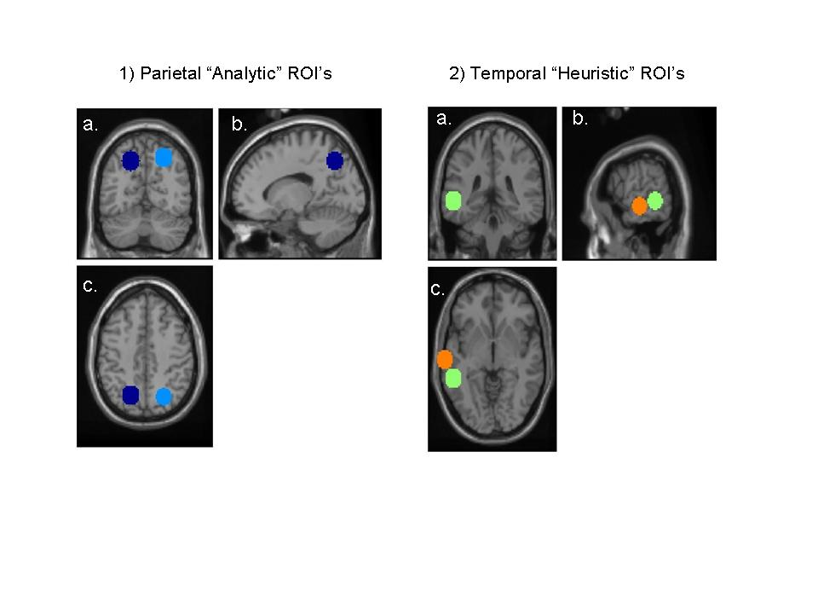
Figure 1. Location of the Regions of Interest (ROI) assumed to be involved in analytic and heuristic decision making superimposed on to coronal (a), sagittal (b), and transverse (c) sections of a magnetic resonance image, which is itself in standard space. Left-hand panels (1) show the position of the Superior Parietal ROI’s (BA7; left in dark blue, right in light blue). Right-hand panels (2) show the position of the posterior (light green) and additional anterior (orange) Left Lateral Temporal ROI’s (BA 21/22).
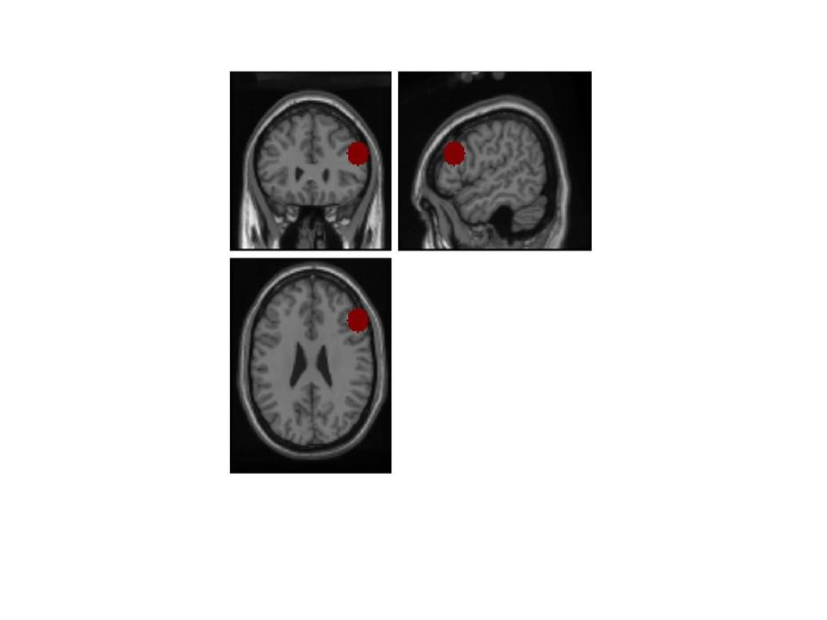

Figure 2. Location of the Right Lateral Prefrontal Region of Interest (BA 46, dark red circle) superimposed on to coronal (a), sagittal (b), and transverse (c) sections of a magnetic resonance image, which is itself in standard space.

Consistent with the traditional decision making literature, responses that are in line with the base rates (i.e., selection of the largest group as most likely answer) were labelled as correct answers. Since the base rates are not informative for the Neutral Analytic items the response that matches the description was considered correct for these items. Note that especially in the case of the classic, incongruent problems the actual normative status of the ‘correct’ response is sometimes debated (Gigerenzer, Hell, & Blank, 1988).
This epoch covers the crucial time interval of interest. On one hand, the crucial conflict between the base rates and conclusion can only start arising once the description is presented. On the other hand, the decision making process should be terminated once the response is entered.

